|  |
| --- |
| FALL 2014 |
| Assignment-3RD |
| **The Slide Scroller** |
| Version # AL-1.0#1  Advanced Web Designing  Instructor: Tom tsiliopoulos  Alwazz Designs. |
| **[PAVITTAR SINGH]** |
|  |



|  |
| --- |
| NOV 15th 2014 |

**Version History**

This Slot machine has been designed with the version #AL-1.0

*VERSION #al-1.0* - November 2, 2014

* **Feature:** Start working on given template mail piolet

*VERSION #al-1.1* - November 3, 2014

* **Feature:** Interface changed with new look.
* **Feature:** Improved behavior for result sheet.
* **Bug fixes:** Assorted styling fixes.

*VERSION #al-1.2* – November 4, 2014

* **Bug fixes:** Over 20 bug fixes for plane direction (left to right).

*VERSION #al-1-3* – November, 2014

* **Feature:** setup the new character.
* **Bug fixes:** Position error fixed.

*VERSION #al-1.4* – November 10, 2014

* **Feature:** New picture for interface has been applied.

*VERSION #Al-1.5* - OCTOBER 13, 2014

* **Feature:** final design.

The slide Scroller has been design to spend some time to have some fun. This game has very good feature. This game is a good application to spend some time for fun.

1. **Game Overview**

*(This game design to have some fun and in this game we have to follow some rules to get good control. In this game we can see the score board and also this game has feature to control the plane with your mouse which is giving good life to this game.)*

1. **Game Play Mechanics**

*(In this application there are no any limitation you can try so many time as you want. This game you have to follow some rules to get good control. You have to keep distance from fireballs and you have to catch the stars. These star can give you good score. Every Single star has 100 marks. How many stars you can catch same as well you will get 100 marks.)*

1. **Browsers**

*(This application can work on any web browser. You can try google chrome, Mozilla Firefox, safari as well.)*

1. **Controls**

*(In this application there are just 2 keys through that we can easily start the game.*

* 1. *Play button: Play button play a vital role to start the application and you can listen the plane engine sound.*
  2. *Instruction button: Before start up the game I just recommend you to read all instruction to get good knowledge about this game.*
  3. *Try Again Button: if any case you lost the game than you still have the option to play the game, you can follow the try again button to get again in sky and you can earn some stars.*

*)*

1. **Saving and Loading**

*(This game does not have the save the data in HDD, either you cannot pause this running game.*

*)*

1. **Interface Sketch**

*(This inter face designed same as game’s looks. So going to put a screen shot of interface.)*

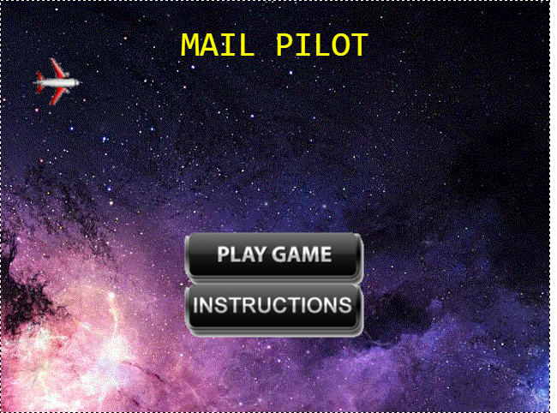

1. **Menu and Screen Descriptions**

*(There are some additional screen shot which can show the working application.)*

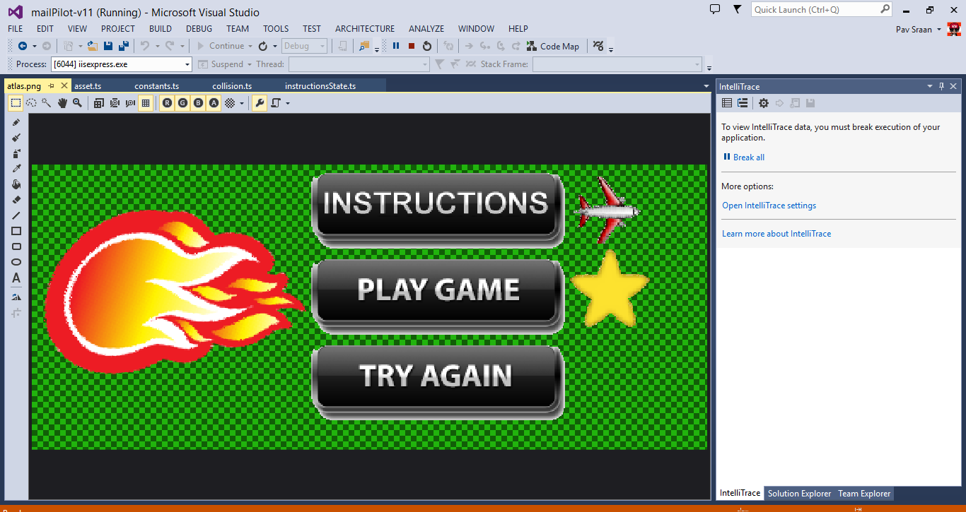

**Screen shot of characters**

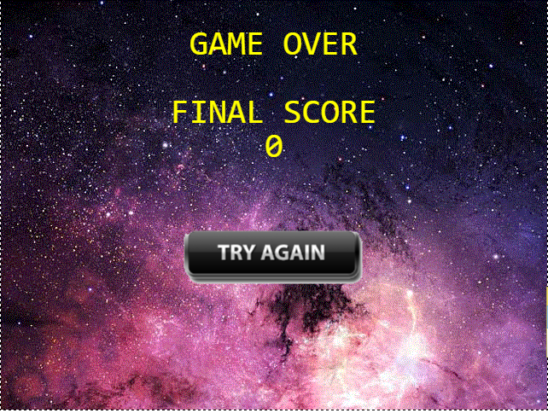

**Screen Short of Try again Option**

**Scoring:** (In this game according to rule of this game we have to earn stars and single star has 100 marks so how many star we can collect or earn than we can see the result with 100. 10 stars = 10 * 100 = 1000.